Amazon
By Artemis and Hera! I have the power to match any man who dares enter our sacred land!

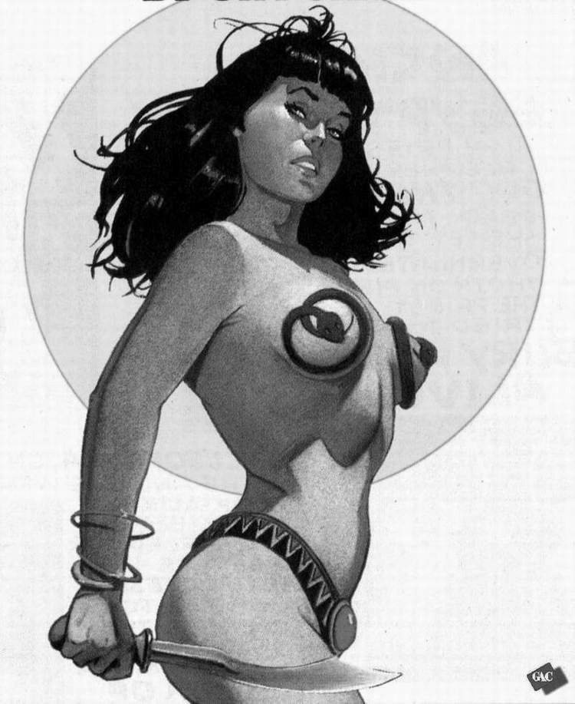
Description
Amazons are a race of women who were blessed by the Greek gods Here and Artemis with incredible strength, wisdom and long life. They excel in the arts of combat, healing and agriculture. Amazons are also well educated and extremely disciplined.

Starting Gear:
Armor or Toga
Weapon
Amazon Jewelry
Water or Wine Skin

“Amazon Heritage”
This Advantage is a rite of caste for a primitive tribe. If the proper vows (determined by the GM) are kept, the character gains +10% to hit male opponents. It also allows participation in Amazon ceremonies and celebrations.

“Bullets and Bracelets”
This advantage allows the Amazon to deflect or redirect missiles using a hand weapon. This allows the character to use the weapon bonus against a missile attack in addition to combat skill. Also the character may attempt a counter strike, In addition, any missile attack that is not defended against successfully, applies (half) the toughness or armor of the weapon in question before the damage from the attack is applied to the character. This ability is subject to the restrictions of the character’s defense class (DC).

This advantage requires the Amazon Heritage Advantage, The Athletics Skills and the Possession of a 40 point fighting skill.

Codes: Crusader, Defender, Fundamentalist, Protector
Contacts: Smuggler, Guide, Pilot, Street Surgeon (Healer), Thug (Bandit)
Wealth Level: Low (does not want for food or shelter).

Beginning Ability Scores
Physique: 60
Intellect: 60
Discipline: 60
Aim Right: 70
Aim Left: 30
Reflexes: 70
Influence: 50
Allure: 60

Toughness: 1d6+2

Starting Skills: Flips, Horsemanship, Swimming, Climbing, Athletics, 40 points combat skill.

Occupational Skills
10 Any Language
10 Music
10 Rope Swings
10 Singing
10 Vaults
20 Giant Swings
20 Hand over Hand
20 Sailing
20 Scouting
20 Stealth
20 Tracking
20 Weapon Making
20 Dives
20 First Aid
30 Religion
30 Survival
40 Aerials
40 Archery
40 Basic Martial Arts
40 Basic Science
40 Battle Master
40 Botany
40 Nerve Strike
40 Occult
40 Stick Fighting
40 Medical

Suggested Powers: Animal Control, Body Control, Command, Foresight, Immortality, Sight
Advantages:
Amazon Heritage (Noir)
Strong Man
Running
Stuntman
Bullets and Bracelets
Ambidextrous
Official Powers
Miracles

